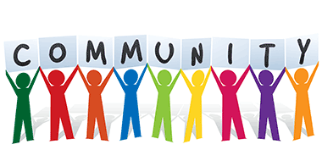

SUPPORTS
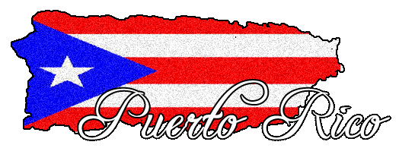

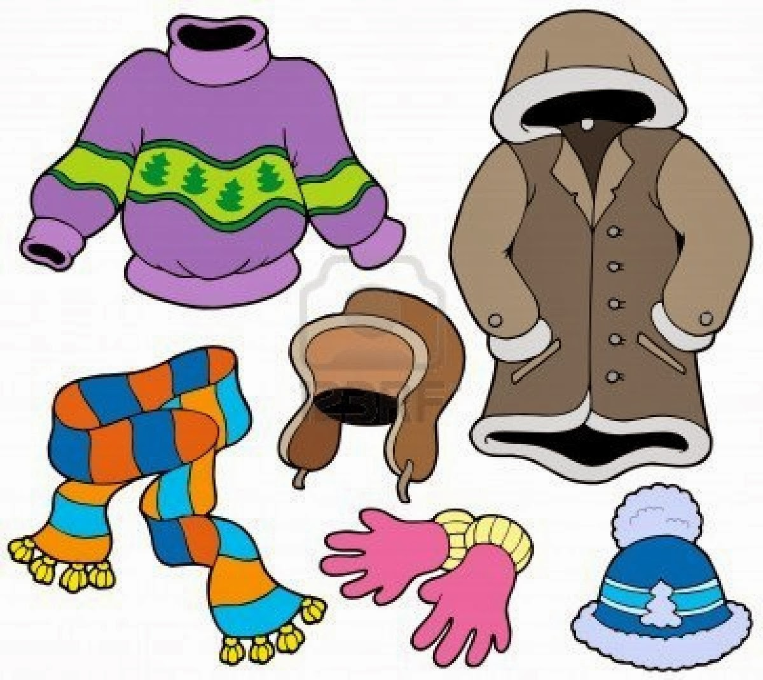

OUTERWEAR & TOILETRY DRIVE
for Tilden families & community members affected by HURRICANE MARIA

Several families will experience Fall and Winter for the 1st time
In partnership with Higher Places Missions
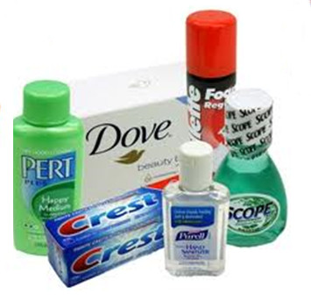
CLOTHING:
New and slightly used coats
NEW hats, scarves and socks
TOILETRIES:
Deodorant, baby wipes, toothpaste, toothbrushes, Vaseline, floss, hand sanitizers, hair care products, lotions, foam soap & dispensers, household and feminine supplies

Collection Site: Tilden Middle School, a Community School

Please contact Community School Coordinator Regina Young at

(215)301-5542 OR regina.young@phila.gov

Collection starting now until Monday, November 13, 2017
#CommunitySchoolsPHL

