

Welcome New Volunteers

FGP would like to wish a warm welcome to our new volunteers:

|  |  |
| --- | --- |
| Barbara D. Barnes | Jacqueline A. Chester |
| Dana M. Daniels | Rebecca Gipson |
| Reva R. Moore | Lorraine Patterson-Burch |
| Linda M. Smith | Mildred Wheeler-Dawkins |
| Judith A. Wooten | |



Fall 2017 Edition

|  |
| --- |
| Table of Contents:   * Some Ways to Help Kids Learn to Love Reading * Mark Your Calendar * FGP Spotlight * FGP Birthdays * FGP Service Anniversaries * At Your Service * Contact Us |
|  |
|  |

A Grandma’s Story

“One of my four year old’s came out of the bathroom (with his clothes intact) and said very loudly, ‘Can somebody wipe my butt?'”

-Grandma Lois Lindsay

Some Ways to Help Kids   
Learn to Love Reading

* Read Aloud: Read to children. Let them read the words they know, but most importantly, read with love, understanding and compassion. Read books that inspire, motivate and books that children love.
* Character voice cards can make reading aloud fun: Use ‘character voice cards’ to practice fluency with repeated reading. The cards range from a whisper to cowboy, robot to their favorite Pokémon character. The student picks a card and there is always a little laughter, but this will motivate the student to read again and again.
* Let the child draw what they are hearing: This can help engage them further in the story.
* Give the child choices of reading materials. Let them choose what they prefer to read. This will increase their confidence and their interests in books and reading.
* Grandparents make great reading buddies: You model good reading skills and encourage the children to stay on task while reading.
* Teach children to care for books and reward them when they do: Take the time to have mini-lessons on how to take care of the books. As the school year progresses you can introduce new books and this gives the students something to look forward to and is a kind of a reward.

Source:https://www.edutopia.org/discussion/37-ways-help-kids-learn-love-reading

At Your Service

Mayor’s Commission On Aging

(215) 686 – 8450

BenePhilly

(844) 848 – 4376

Mayor’s Commission On Literacy

(215) 686 – 5250

Philadelphia Corporation for Aging Helpline

(215) 765 – 9040

When in doubt…call 311

CONTACT US…

Foster Grandparent Program

100 South Broad Street, Room 432

Philadelphia Pa 19110

Fax: (215) 685 – 3653

Linda Lane

Program Coordinator

(215) 685 – 3798

[Linda.Lane@Phila.Gov](mailto:Linda.Lane@Phila.Gov)

Laura Grassia

Program Director  
(215) 685 – 3799

[Laura.Grassia@Phila.Gov](mailto:Laura.Grassia@Phila.Gov)

FGP BIRTHDAYS

|  |  |  |
| --- | --- | --- |
| **September** | **October (cont.)** | **November (cont.)** |
| Margaret Carter – 2nd | Dorothy Gibson – 19th | Sheila Thomas – 18th |
| Bernadette Seals – 7th | Linda Knox-Ford – 22nd |  |
| Rosa Campbell – 9th | Margaret Hunter – 23rd | **December** |
| Theresa Grant – 18th | Florence B. Sutton – 25th | JoAnn Guy – 2nd |
| Darlene Price – 18th | Loretta Bernard – 30th | Yvonne M. Combs-Hogan – 7th |
| Barbara Barnes – 20th |  | Isabella Williams – 7th |
| Edith Scott – 30th | **November** | Elmer Abraham – 14th |
|  | Lillian Gresham-Bundy – 1st | Juanita F. Armstrong – 18th |
| **October** | Edna Pugh – 1st | Edith M. Jackson – 21st |
| Carol Rivers – 6th | Linda M. Smith – 2nd | Eleanor Jackson – 23rd |
| Loretta Jones – 7th | Darlene Peterson-Muir – 3rd | Deborah F. Lloyd – 23rd |
| Chinita Bradshaw – 8th | Lois Justice – 5th | Marian Hinton – 24th |
| Shirley Pennington – 9th | Clara M. Parks – 5th | Dana Daniels – 26th |
| Janet Lambert – 10th | Roxanne Horsey – 7th | Ursula Cooper – 27th |

*Editor’s Note: Regrettably, I left out Sadie Murray’s birthday on April 1st

Wishing you all joyous birthday wishes and a beautiful year ahead!

MARK YOUR CALENDAR

* Monthly MANDATORY In-Service*
  + Friday, October, 20, 2017
* Monthly MANDATORY In-Service*
  + Friday, November 17, 2017
* Monthly MANDATORY In-Service*
  + Friday, December 15, 2017

*In-services are held at the Blue Cross Building at 1901 Market Street, 23rd Floor

Rooms G, H & I from 10am to 2pm.

* Mentoring 101: How to Be an Effective Mentor-Get the skills and strategies you need to be an effective mentor!
  + Thursday, October 13, 2017*
  + Monday, October 30, 2017*
  + Friday, November 10, 2017*

*Training will take place in the Municipal Services Building, 1401 JFK Blvd., 16th Floor, Room Z from 10:00am to 2:00pm. Lunch will be provided. Please bring your ID.

**Please refer to your letter that designates your date to attend!**



FRIENDLY REMINDERS

* Foster Grandparent volunteers must volunteer a minimum of 15 hours a week and a maximum of 40 hours a week. If you volunteer less than 15 hours a week for 3 pay periods, you will receive a warning letter. If you continue to volunteer less than 15 hours a week after receiving the warning letter, you will be placed on probation.
* Please do not adjust your volunteer hours (increase or decrease) without approval from the Foster Grandparent Program. Please call Linda Lane (215) 685-3798 for this approval.
* After 3 consecutive sick days off, please provide a note from your Doctor. This is for your and the children’s protection!
* In the event of a death in the family, please provide a note from the funeral director stating your relationship to your loved one.

Please note: Inservices are mandatory and monthly. Please attend!   
You are paid for this time and important program information is passed on at the meetings.

FGP SERVICE ANNIVERSARIES

The following Grandparents are celebrating their Service Anniversaries in the months of September, October, November and December:

|  |  |  |
| --- | --- | --- |
| 17 Years of Service | 8 Years of Service | 4 Years of Service (cont.) |
| Juanita F. Armstrong | Alberta Fortson | Marie Romero |
| Edith M. Jackson | Janet Lambert | Bernadette Seals |
|  |  | Mary Louise Sessoms |
| 14 Years of Service | 5 Years of Service | Andrea Williams |
| Irene Gaskins | Juanita Holt | 2 Years of Service |
|  | Bessie M. Pollard | Chinita Bradshaw |
| 10 Years of Service | Edna Pugh | Elaine Jones |
| Gloria L. Harris | Lillie Smith | Ada Marrero |
| Helen L. Hood |  | Jean Metz |
| Sadie Murray | 4 Years of Service | Sheila Tisdale |
| Shirley Pennington | Veronica I. Harley |  |
|  | Toinettie M. James | 1 Year of Service |
|  | Clara M. Parks | Edith Scott |

MENTOR TRAINING



We are pleased to announce that The Foster Grandparent Program has formed a partnership with the Mentoring Partnership & Resource Center. They will be conducting a training called MENTORING 101: HOW TO BE AN EFFECTIVE MENTOR.

Get the skills and strategies you need to be an effective mentor!

In this comprehensive & interactive training, you will:

* Understand and apply research based practices on mentoring
* Understand and gain strategies for navigating the stages of a relationship
* Understand how to create a supportive environment, including
  + Applying positive communication skills,
  + Strategies for developing a growth mindset,
  + Developing and maintaining healthy boundaries

The training dates will be on:

* Thursday, October 13, 2017
* Monday, October 30, 2017
* Friday, November 10, 2017

Trainings will be held at the Municipal Services Building, 1401 JFK Blvd., 16th Floor, Room Z from 10:00am to 2:00pm. Lunch will be provided. Please bring your ID.

You will receive a notice that will let you know when you are to report for training. If you have a conflict with your scheduled date, please contact the Foster Grandparent Program office immediately. There is limited space for each training date.

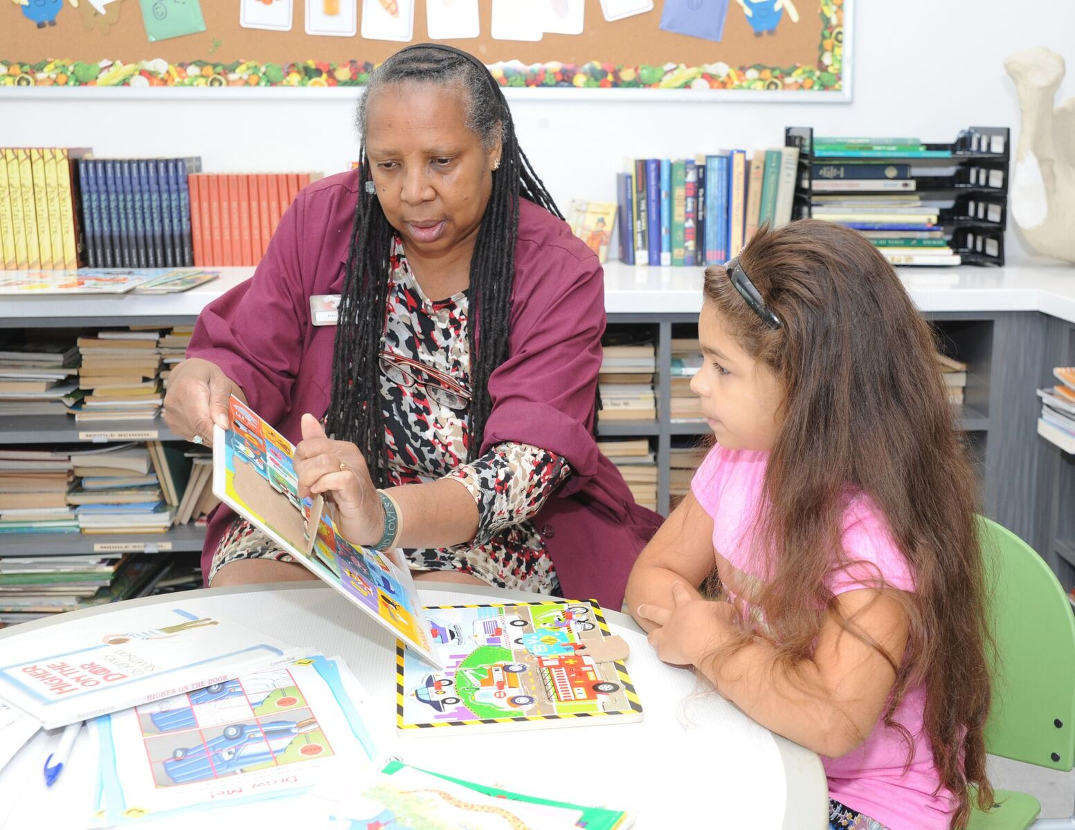

FGP SPOTLIGHT

Butterflies everywhere! Science class is the best! Ms. Yvonne Combs-Hogan’s kids at T. M. Pierce Elementary School are studying the cycle of life by watching catepillars hatch into beautiful butterflies.

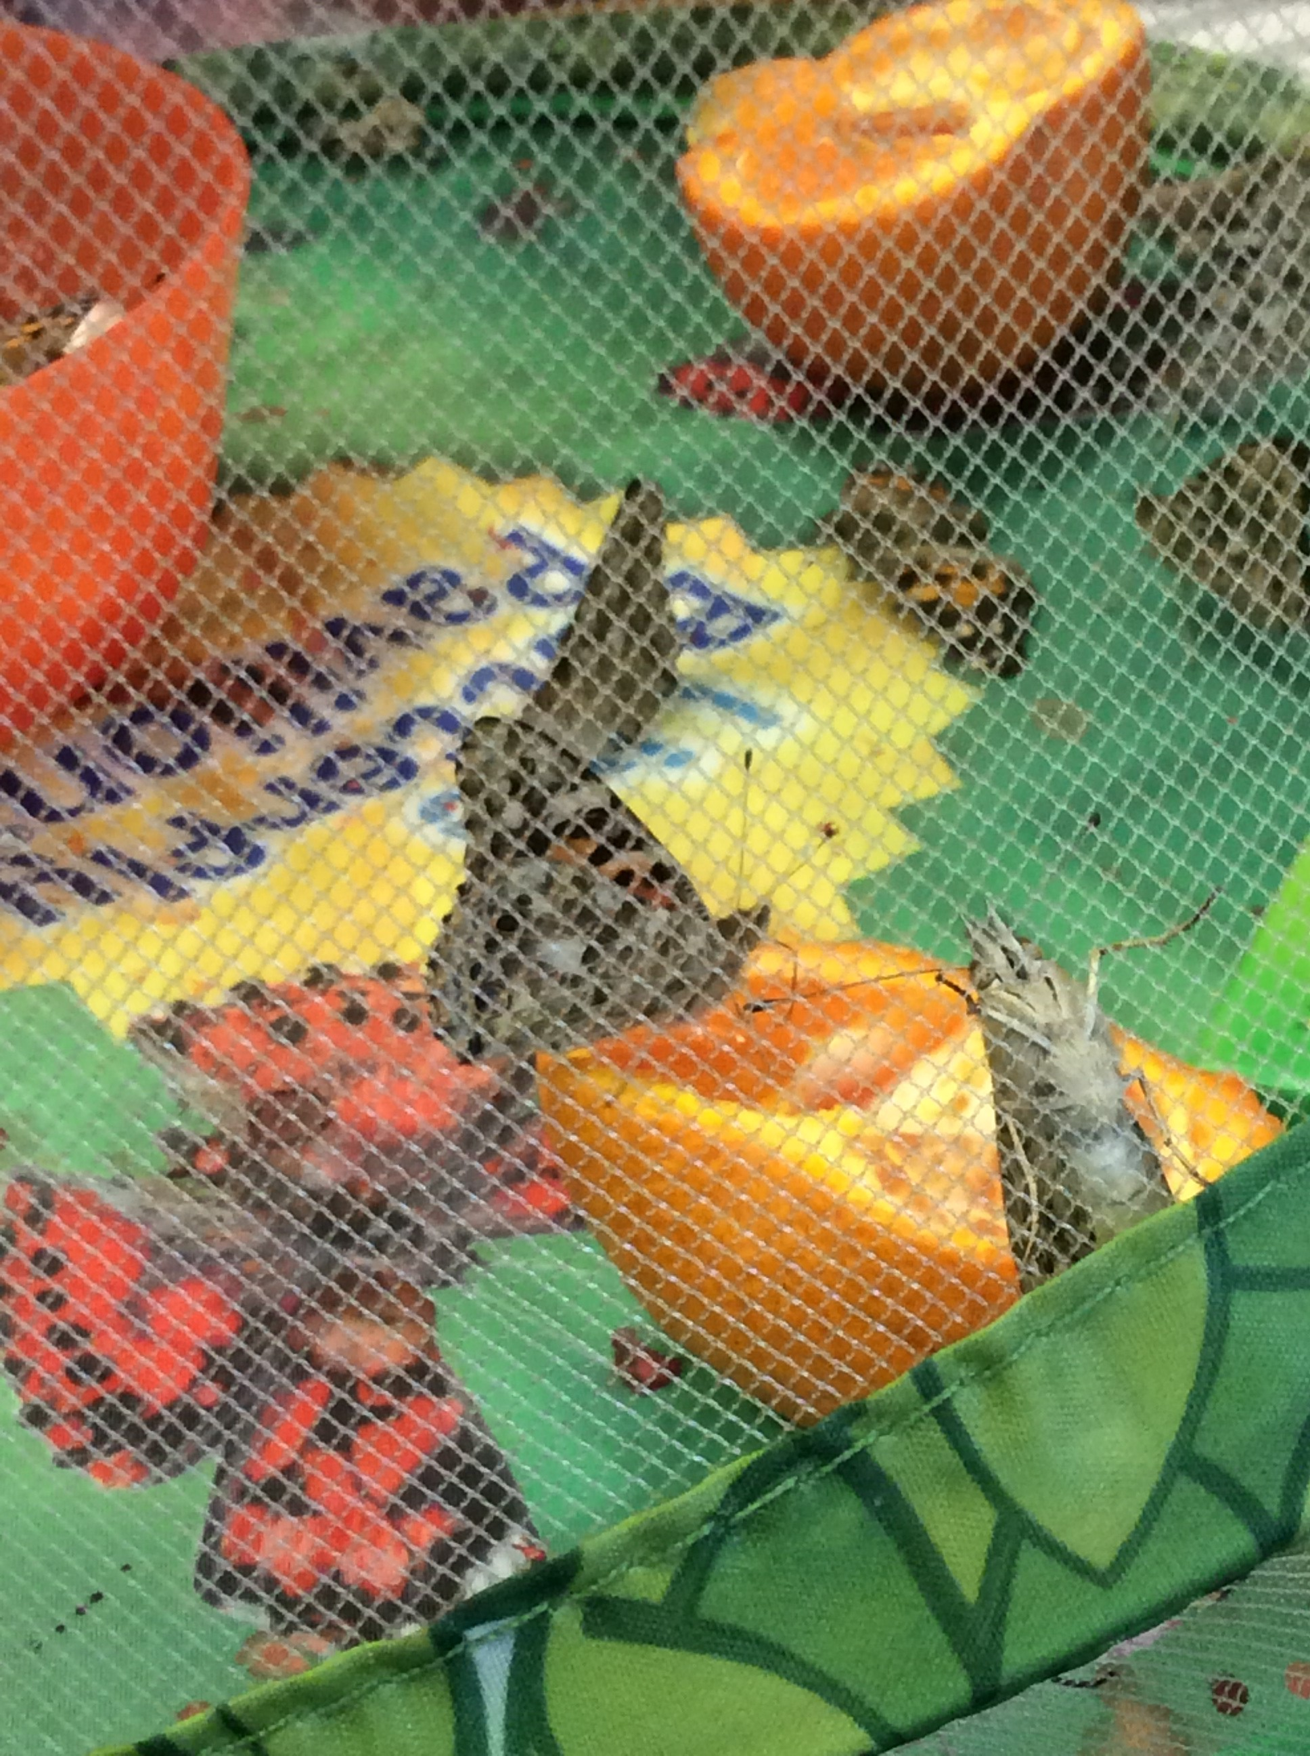 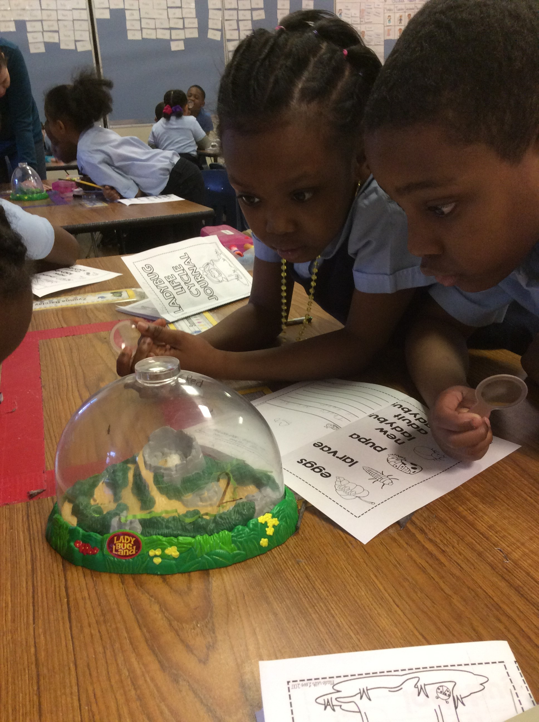

Show and Tell: Momma Hen sits on a container that contains her eggs. They will soon spend 7-10 days in an incubator at 99 to 102 degrees Fahrenheit. This is a perfect environment for the embryos to grow. After 7-10 days in the incubator, the eggs are candled. This process will let the children see if an embryo has formed in the egg. In about 12-14 days after candling, the chicks inside will “pip” there way out of their shells and chirp “Hello” to the world!

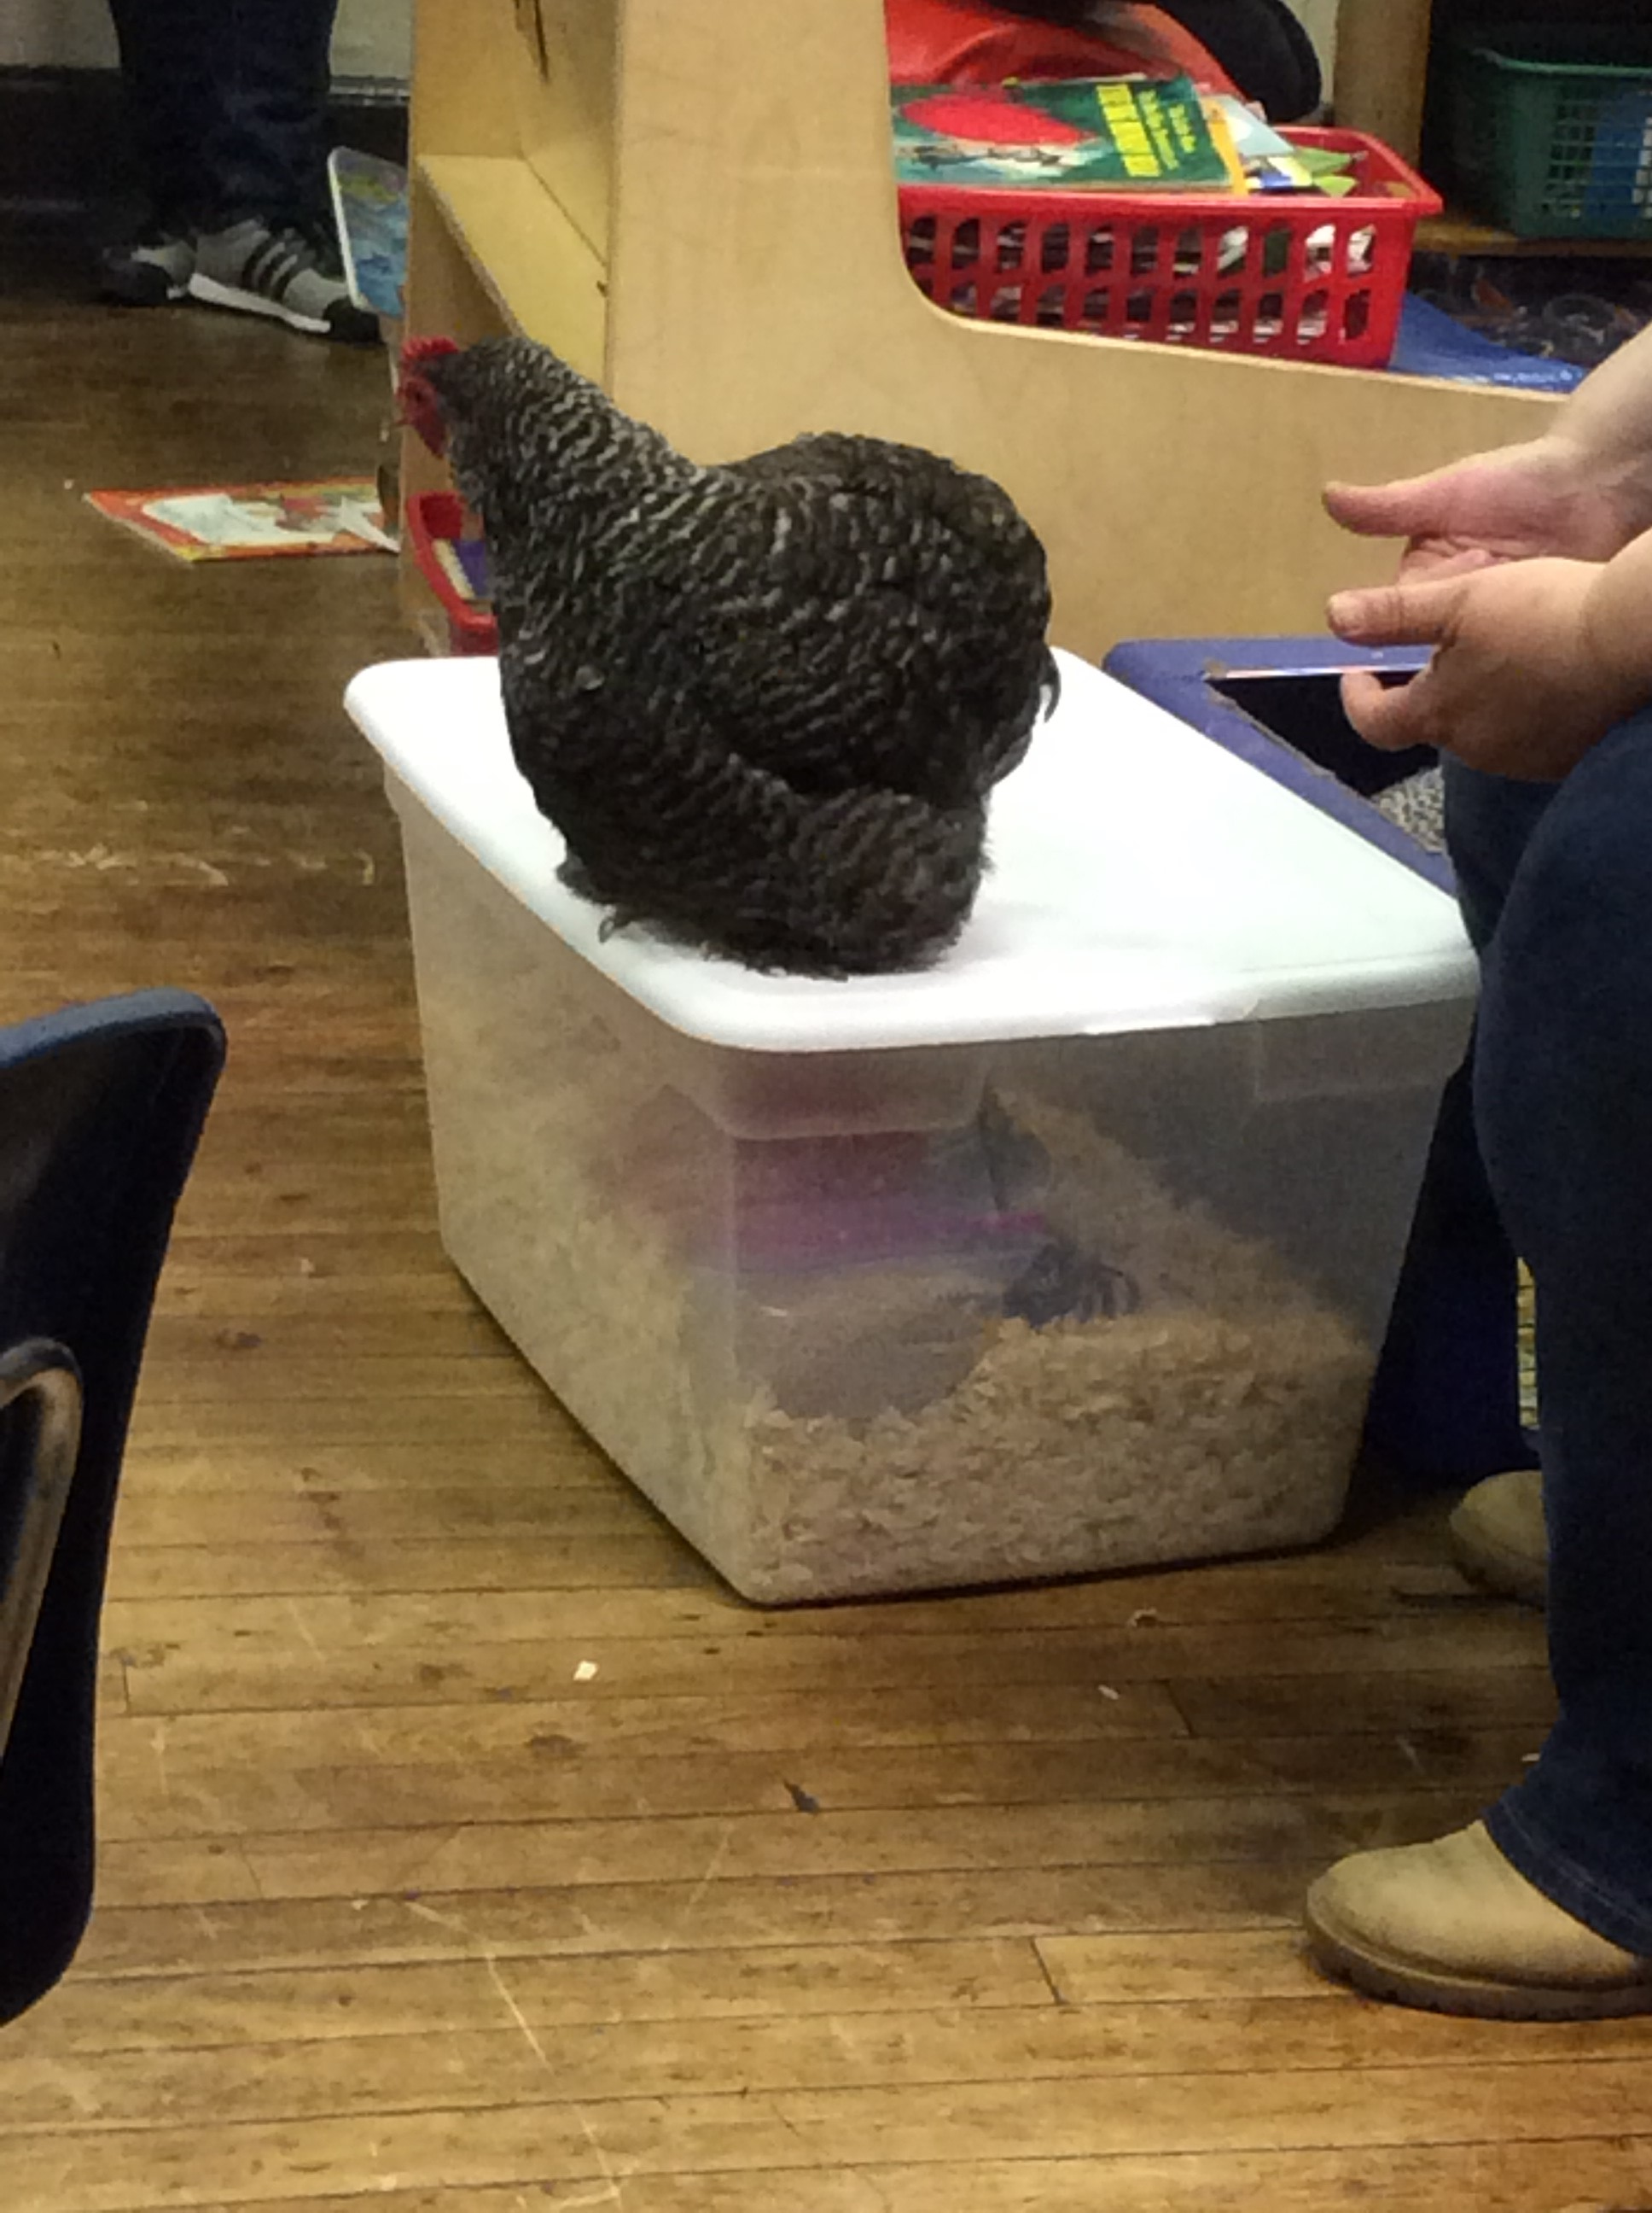 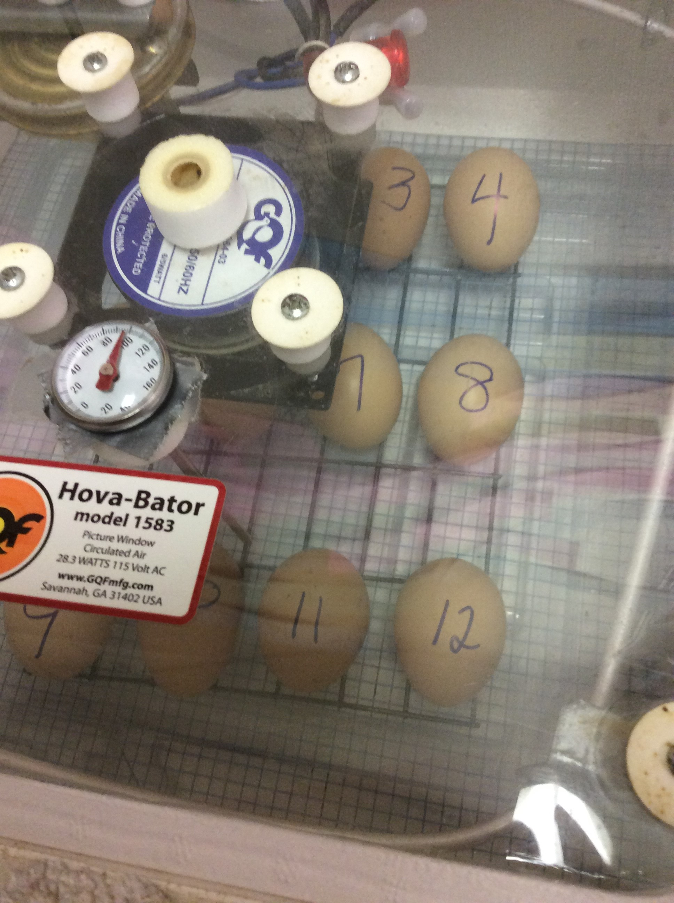

If you would like to submit pictures from your classroom for the FGP Spotlight, please submit them to [laura.grassia@phila.gov](mailto:laura.grassia@phila.gov) or text the picture to (215) 327-7700.